# **UK Road Safety Data Analysis**

Road safety means the protection and security of all those who travel on roads. No one would argue with the steps towards stop deaths on the roads. The UK and many other developing countries, the importance of making road safety a global development priority hits home; especially after a string of dramatic crashes that have made headlines across the country and increasing year by year.

All over the planet, a traffic crash is called an accident. An accident is “an unforeseen and unplanned event or circumstance.” Most traffic crashes are due to human error, whether it is because of impaired driving, distracted driving, speeding or even driver inattention. A collision because of impaired driving is not unforeseen. A crash because of distracted driving is not unexpected, nor is a crash caused by speeding or drowsy driving. A fatality because a person didn’t wear a seatbelt is foreseeable. All these actions are known to cause accidents and deaths. The result of these actions is predictable and preventable; by analysing historical data and learnings from incites driven by historical fact data.

The agenda of this use case is to analyse the UK road safety data to identify reasons and conditions causing accidents.

Key analysis areas are:

1. Analysing accidents trends over time (Hourly, Daily, and Yearly) based on severity category (Fatal, Serious and Slight).

2. Identifying the top twenty location, where attention is required, and digitalised advertisements required.

3. Analysis number of accidents on attributes like age, gender, speed limit, junction, and journey purpose.

4. Analysing significant factors to identify the accident causes are: type of vehicle, road conditions and area (urban, rural and other).

## Slide-1:

A total of 1,792 peoples were killed in reported road traffic accidents in the UK in 2016, which is increased 4 percent from 2015 and over a year time, the number of seriously injured people in the UK rose to 252494 from 140056 (the year 2015 to 2016).

Fridays have a slightly higher rate of accidents than other days in a week.

In a day on average of accidents rated each hour of the day, more accidents recorded at two-time intervals are: 3 pm to 6 pm followed by 6 am to 9 am. The chart, therefore, indicates what times of the day and week have a higher risk of fatalities. This is not necessarily the same time of the day as when the most accidents occur. It is likely that the highest number of accidents will happen during the busiest times of the day when there is a lot of traffic on the road.

Whereas severity concerned, category slight recorded 83.71%, Serious is 15.09% and fatal 15.09% on average over two years.

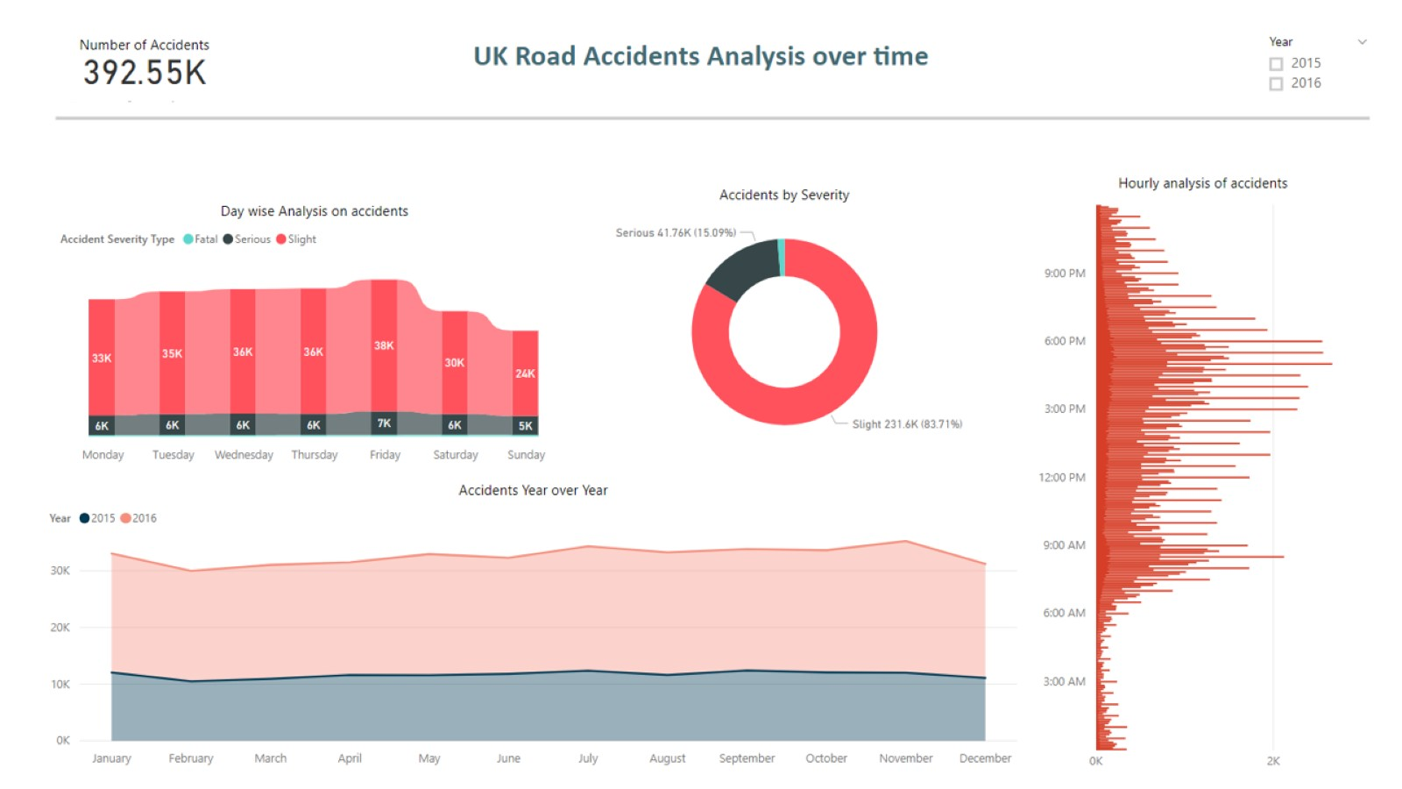

Figure 1. Accidents analysis based on time frame.

## Slide-2:

From the given data, top twenty district locations identified on average accidents recorded; where more awareness programs required ,like placing several digital advertising boards. Areas need more attention from road safety authorities’. Highest accidents recorded in London city followed by Southampton and Manchester area, and on.

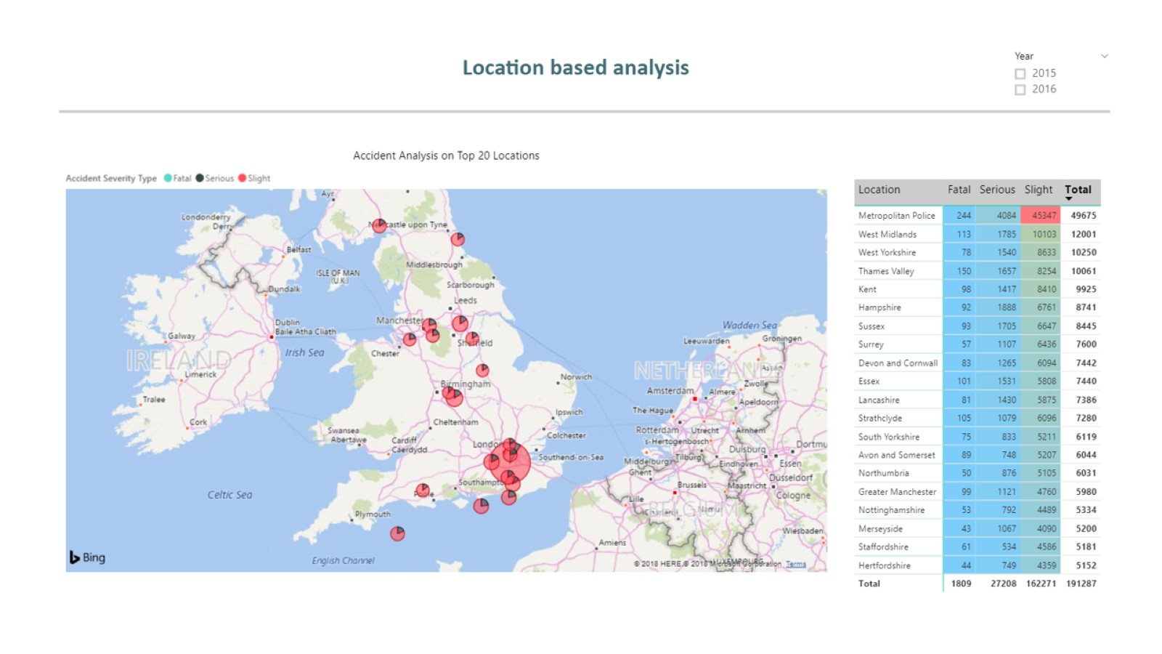

Figure 2. Analysis to identify 20 local authority districts to place several digital advertising boards.

## Slide-3:

Age groups, drivers on age group 20’s are recorded as highest accidents rate, followed by age group 30 to 50. Whereas age group 80’s filed lowest rare followed by 70’s.

The speed limit, high in the number of accidents taken place at speed zones’ 30 followed by 60… and at speed limit 20 recorded low accident rate.” In 2016, young drivers (16-24-year-olds) only accounted for about 7 percent of all full driving licence holders in Great Britain. Yet in the same year, they were involved in crashes where 25 percent of all those people killed and seriously injured were hurt.

In 2016, there were 448 fatalities in collisions involving at least one young driver, roughly a quarter of all reported road fatalities. Young drivers themselves accounted for 40 percent (180) of these fatalities and the passengers in their cars a further 20 percent (88).

It is worth noting that these casualties were not necessarily inflicted by a young driver, or directly related to the young driver personally in any way; they simply occurred as a result of a crash in which a young driver was involved.” (News Paper)

Gender wise analysis, Men, recorded more number of accidents of all categories than women and not specified.

Junction rational analysis, more number of accidents taken place 20 meters to junctions, approaching junctions and at roundabouts.

Careless, reckless or in a hurry was the third common contributory factor allocated to reported fatalities. Purpose of travel analysis, there are infinite factors that influence driver’s mental status, and accidents happen with human’s mistakes. From the data analysis more, number of accidents recorded on purpose, journey as a part of work and commuting from work/to work.

Finally, analysis of the type of vehicles most involved in a collision. Cars are identified as more numbers of an accidents rate as high number in use followed by cyclists, and the safest vehicle is tram also lesser stress on driving and high safety values.

“The Public Transport sector caters to thousands of travellers each day, each of them on their journey. Whether this is commuting to and from work, a trip to the shops or a getting home responsibly after a night out, Securitas work to ensure that all journeys are regulated, to ensure the safety and security of staff and travellers alike.”

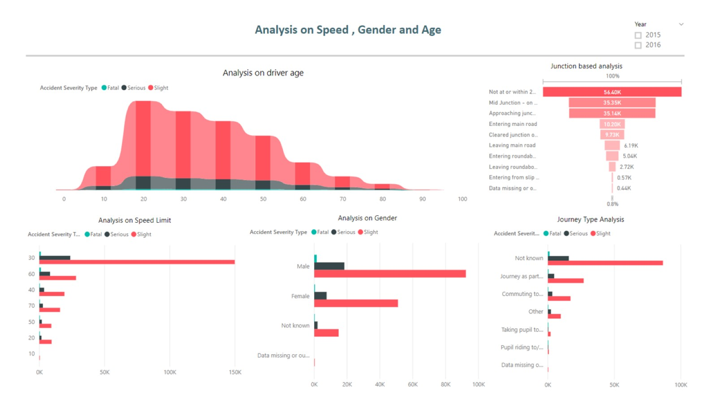

Figure 3. Analysis to find the correlation between demographic data and road accidents

## Slide-4:

Road types, according to the data more accidents recorded on dry roads and wet or damp roads. Serious accidents are 10% on dry and 4% on wet roads.

Area wise analysis states contrast, fatalities on urban roads; urban areas have higher accident rate than rural. Rural roads carried the majority of car traffic (42 percent) followed by urban roads (32 percent) and motorways (20 percent).

Accidents that occur on rural roads are more likely to be of a fatal nature in comparison with those on urban roads. This is because of the difference in the average speed on different roads. Rural roads have a much higher average speed than urban roads. Rural roads are often much more sinuous and narrow in nature with blind bends, dips and other distractions. Accidents at lower speeds on urban roads are less likely to result in serious injuries or fatalities. This is borne out by the fact that the fatality rate for road deaths is higher on rural roads than on urban roads; despite the higher number of vehicle interactions on urban roads.

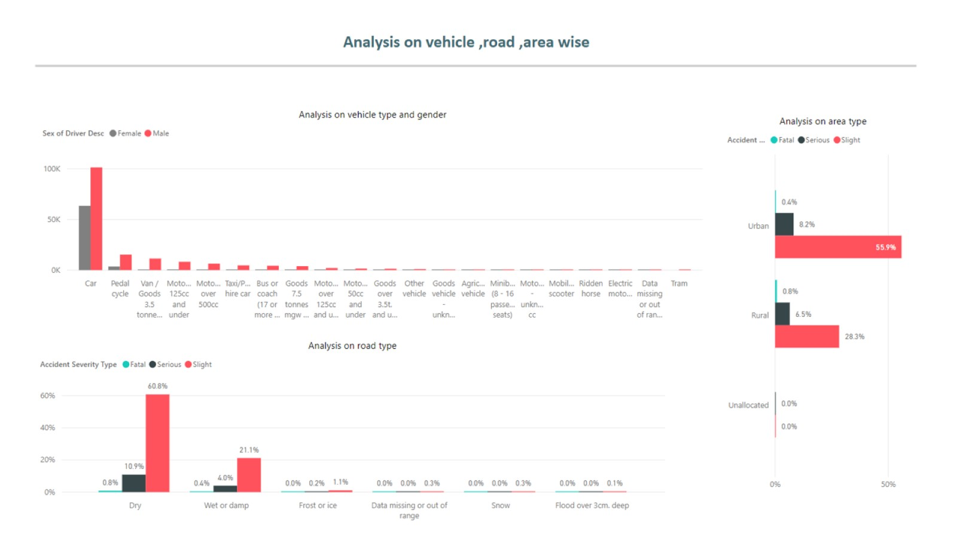

Figure 4. Analysis to find the correlation between demographic data and road accidents( area, vehicle type and road conditions)

## Data Modelling and Processing:



Figure 5. Data modelling and pre-processing.